**SAMPLE OUTPUT**

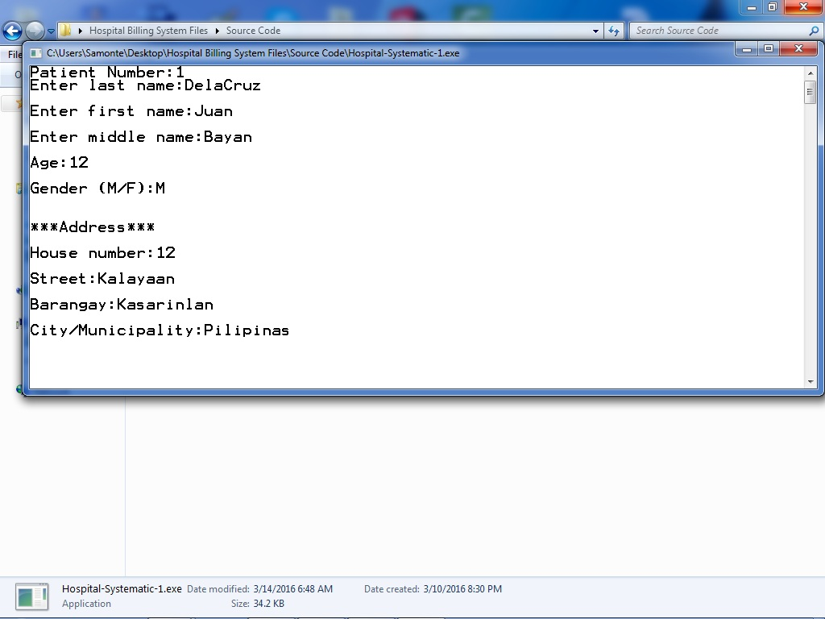

Admitting a patient

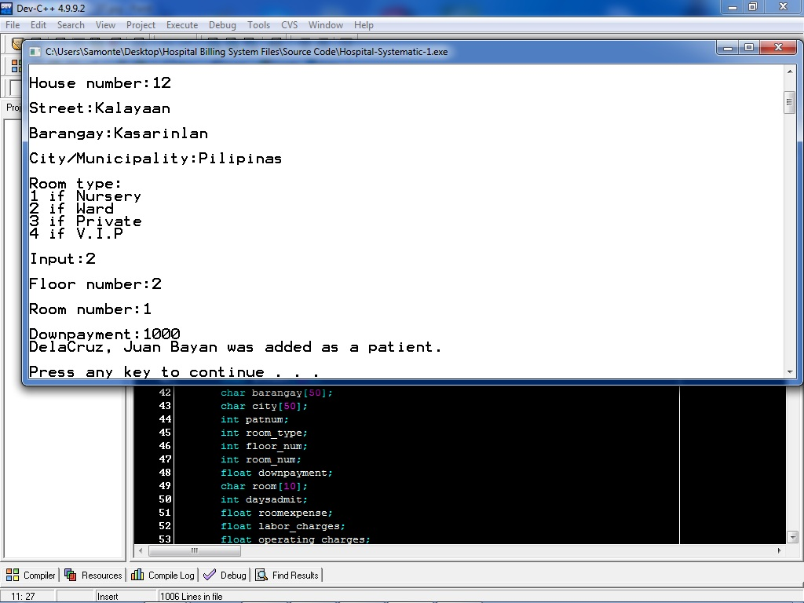  
Patient number 1  
(DelaCruz, Juan Bayan) was successfully added

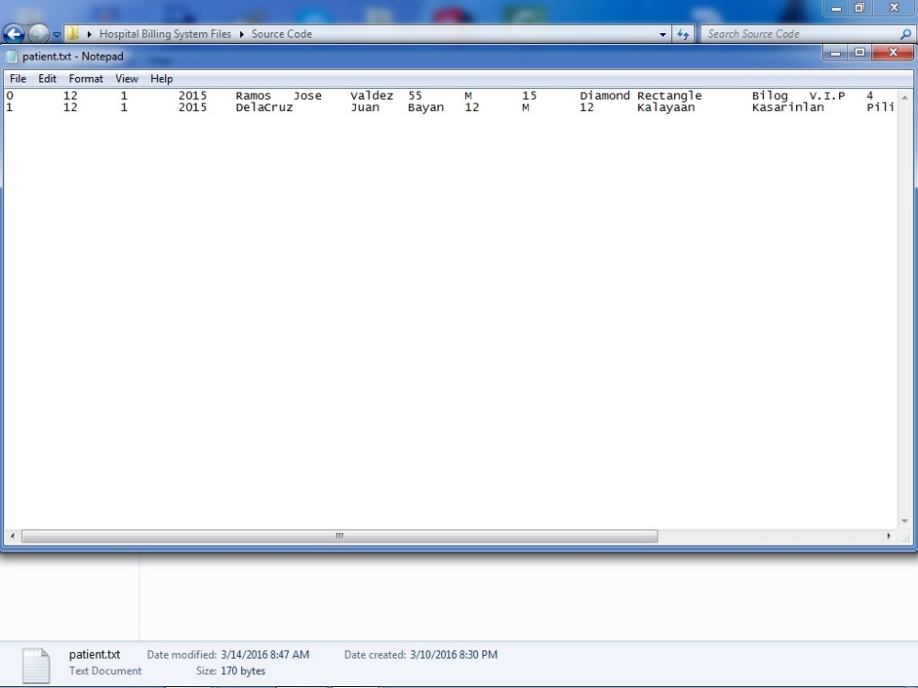

Patient number 1  
(DelaCruz, Juan Bayan) was successfully added into the text file named “patient.txt”